**Answer Key**

400

400

1.

2.

3. 

4. 24*i*

5. 10

6. or

7. 

8. 13

9. 3

10. 

11. 

12.

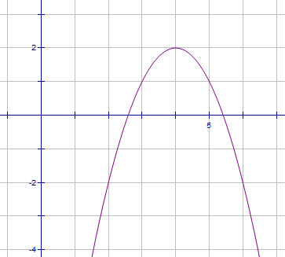

13.

14.

15.

16.

17. 

18. x =

19. 36

20. 4

21.

22.

23.

24.

25.

26. –123

27. 682.75

28.

29.

30. 112.03

31. shifted right 4

32. shifted left 2, down 3

33. *x* = –3

34.

35. Answers may vary



36. VA: *x* = –3 , *x* = 1

HA: *y* = 2

51.

52.

53. 

54. 30

55. 36

56.

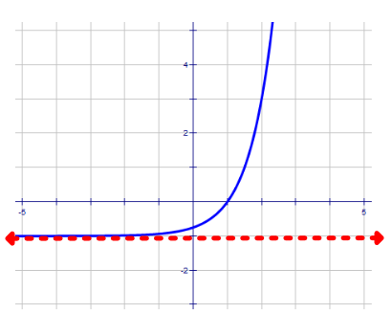

57. Graph of 

58. 0.1992

59. –0. 22

60. 5log9*x* – 2log9(*y*–1) – 3log9 *z*

61.

62. 

63. $19,477.65

64. 1137.72 micrograms

65. 3.94

66. 87

67. a.) 69.57%

b.) 27.06%

c.) 33.33%

68. 84.1, 85, 89, 37

69.

70.

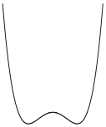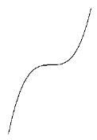[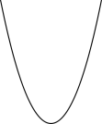](http://www.google.com/url?sa=i&rct=j&q=&esrc=s&frm=1&source=images&cd=&cad=rja&docid=GT4SR60ZdeHSgM&tbnid=cN0MRFPNlYm73M:&ved=0CAUQjRw&url=http://wiki.ubc.ca/User:SteffanyChwedoruk&ei=yYBZUaWGHLjj4AOt7ICgDA&bvm=bv.44442042,d.dmg&psig=AFQjCNHV0oN8ArCi3d5EHCt_DJsuIJrxmw&ust=1364906565049106)

37. VA: x = 3

HA: y=1

38. (

39.

40. 

41.

42. 

43. Degree 2:

Degree 3:

Degree 4:

44.

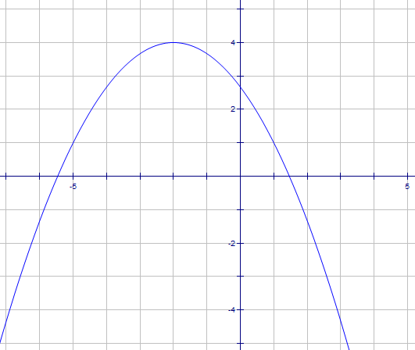

45.

46. 

47. *x* = 0, 1, 2, –3

48. 

49. 

50.